CMPT 365 – Project Report

Link to video: <https://youtu.be/FGZkPaibSSw>

# File Chooser & Opener

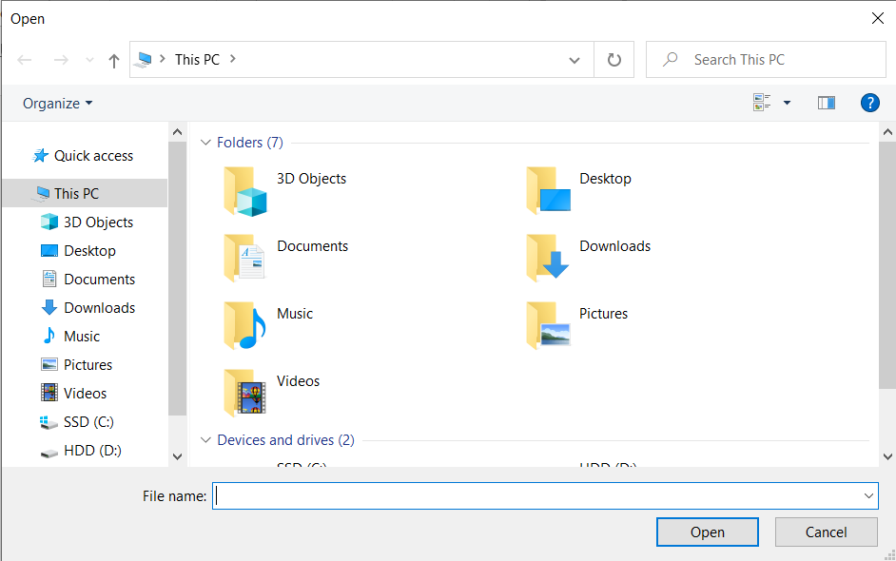Using functions openImage and grabFile, this feature allows the user to select which file he wants to open and opens any popular video file format ( .mp4, .avi, .mov, .mpeg, and .wmv) when the user presses the open button. The windows file explorer pops up when the open button is pressed as shown below.

# 1.1 STI by Copying Pixels

Using functions R, C (buttons), and createRowCol, we create the STI. The createRowCol function is called by the frame grabber each frame and the STI is created by copying pixels to appropriate locations.

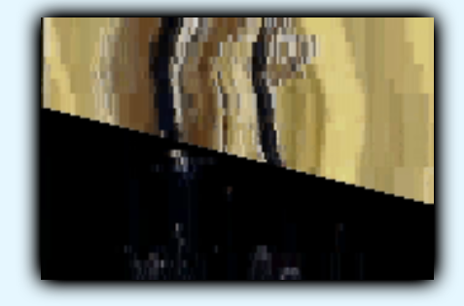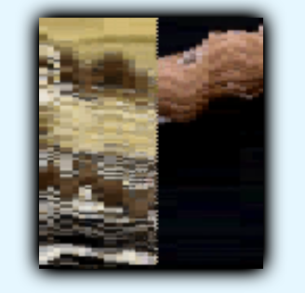 Row STI Column STI

# 1.2 STI by Histogram Difference

Using functions HR, HC (buttons), chromaticity, histDiff, createHistogram and histSTI, this feature is implemented. Chromaticity is called each frame by the frame grabber to calculate the chromaticity value of each frame. HistSTI is called at the beginning and calls two functions: histDiff so the I variable can be calculated, and createHistogram so it can fill the histograms. The histSTI function also turns the frames into frame number of rows and columns, to complete the image.

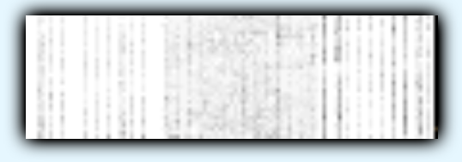Row Histogram

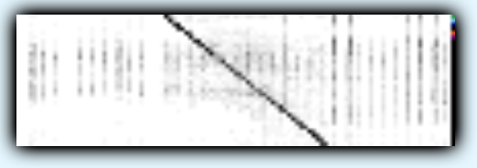Column Histogram

# Interface

Some minor UI enhancements were made to make it easier on the user’s eyes. We recolored the interface and organized the buttons in a nice format.

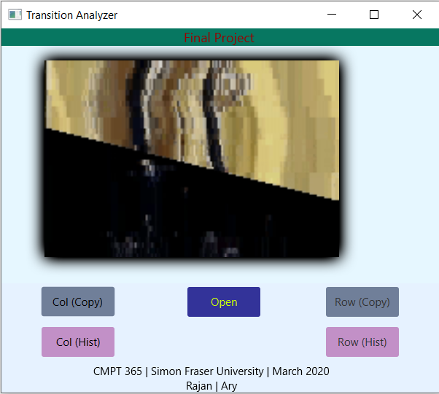

# Comments

This project was made in Java with OpenCV and JavaFX with Scenebuilder just as assignment 2. The project itself was quite difficult and took a lot of time to complete. The pixel copying STI part was not too difficult and was intuitive. The histogram part took a while to understand but it eventually came to us. The programming for this part was difficult and took up the vast majority of the time that we put into this project. I would say that the difficulty is a bit higher than we anticipated and we would’ve preferred something slightly easier, however, it was not impossible.